

Department | ID | NAME
NT | 23014331 | محمد حمدالله صالح حمدالله
NT | 23016039 | جمال عبد الناصر ثابت عبد الجواد
NT | 23018238 | احمد شعبان طنطاوي حافظ
NT | 23013413 | احمد سليمان احمد عشماوي

Supervisor
Dr: Aymen Hassanin
ENG: Mohamed Amer
ENG: Ahmed Abdelmonaem
ENG: Nada

October 6 university
Faculty of Information Systems and Computer Science
SALES SYSTEM

T

1.0 System Description
A fully integrated sales system designed to manage sales, purchases, invoices, inventory, and reports through multiple linked interfaces that ensure smooth operation and fast access to accurate data.

1.1 Interface 1: Point of Sale (POS)1.0 System Description
A fully integrated sales system designed to manage sales, purchases, invoices, inventory, and reports through multiple linked interfaces that ensure smooth operation and fast access to accurate data.

1.1 Interface 1: Point of Sale (POS)
This is the main screen used to perform sales operations.
Features:
- Displays all available products with organized view.
- Each product contains price, description, code, category, and available quantity.
- When a product is selected, it is added directly to the shopping cart.
- Ability to modify quantity, remove items, or apply discount if needed.
- After confirming the purchase, an invoice is generated and automatically transferred to the Sales Invoices interface.

1.2 Interface 2: Sales Invoices1.1 Interface 1: Point of Sale (POS)1.0 System Description
A fully integrated sales system designed to manage sales, purchases, invoices, inventory, and reports through multiple linked interfaces that ensure smooth operation and fast access to accurate data.

1.1 Interface 1: Point of Sale (POS)1.0 System Description
A fully integrated sales system designed to manage sales, purchases, invoices, inventory, and reports through multiple linked interfaces that ensure smooth operation and fast access to accurate data.

1.1 Interface 1: Point of Sale (POS)
This is the main screen used to perform sales operations.
Features:
- Displays all available products with organized view.
- Each product contains price, description, code, category, and available quantity.
- When a product is selected, it is added directly to the shopping cart.
- Ability to modify quantity, remove items, or apply discount if needed.
- After confirming the purchase, an invoice is generated and automatically transferred to the Sales Invoices interface.

1.2 Interface 2: Sales Invoices1.1 Interface 1: Point of Sale (POS)
This is the main screen used to perform sales operations.
Features:
- Displays all available products with organized view.
- Each product contains price, description, code, category, and available quantity.
- When a product is selected, it is added directly to the shopping cart.
- Ability to modify quantity, remove items, or apply discount if needed.
- After confirming the purchase, an invoice is generated and automatically transferred to the Sales Invoices interface.

1.2 Interface 2: Sales Invoices1.1 Interface 1: Point of Sale (POS)
This is the main screen used to perform sales operations.
Features:
- Displays all available products with organized view.
- Each product contains price, description, code, category, and available quantity.
- When a product is selected, it is added directly to the shopping cart.
- Ability to modify quantity, remove items, or apply discount if needed.
- After confirming the purchase, an invoice is generated and automatically transferred to the Sales Invoices interface.

1.2 Interface 2: Sales Invoices1.1 Interface 1: Point of Sale (POS)
This is the main screen used to perform sales operations.
Features:
- Displays all available products with organized view.
- Each product contains price, description, code, category, and available quantity.
- When a product is selected, it is added directly to the shopping cart.
- Ability to modify quantity, remove items, or apply discount if needed.
- After confirming the purchase, an invoice is generated and automatically transferred to the Sales Invoices interface.

1.2 Interface 2: Sales Invoices
All invoices created through the POS are stored here.
Features:
- View all past sales invoices.
- Full invoice details (date, products, prices, totals, payment method).
- Search and filter by date, invoice number, product, or customer.
- Ability to reprint or refund a sale if required.

1.3 Interface 3: Reports Dashboard
A powerful analytical dashboard to track system performance.
You can generate:
- Daily / Weekly / Monthly / Annual sales reports
- Profit and loss report based on buying and selling margins
- Top-selling and most demanded products
- Current inventory value and remaining product quantities
This interface supports strategic decision-making with accurate numbers and analytics.

1.4 Interface 4: Product Management
Administrative interface for adding and modifying products.
Features:
- Add new product (name – price – description – quantity – image – category)
- Edit existing product details (price, description, code, stock)
- Delete or deactivate unavailable products
- Product information is linked directly to sales and purchases for automatic stock updates

1.5 How the System Works Together
✔ Sales → Generates invoices automatically
✔ Reports → Analyze business performance
✔ Product Management → Updates and controls inventory data

Usecase Diagram
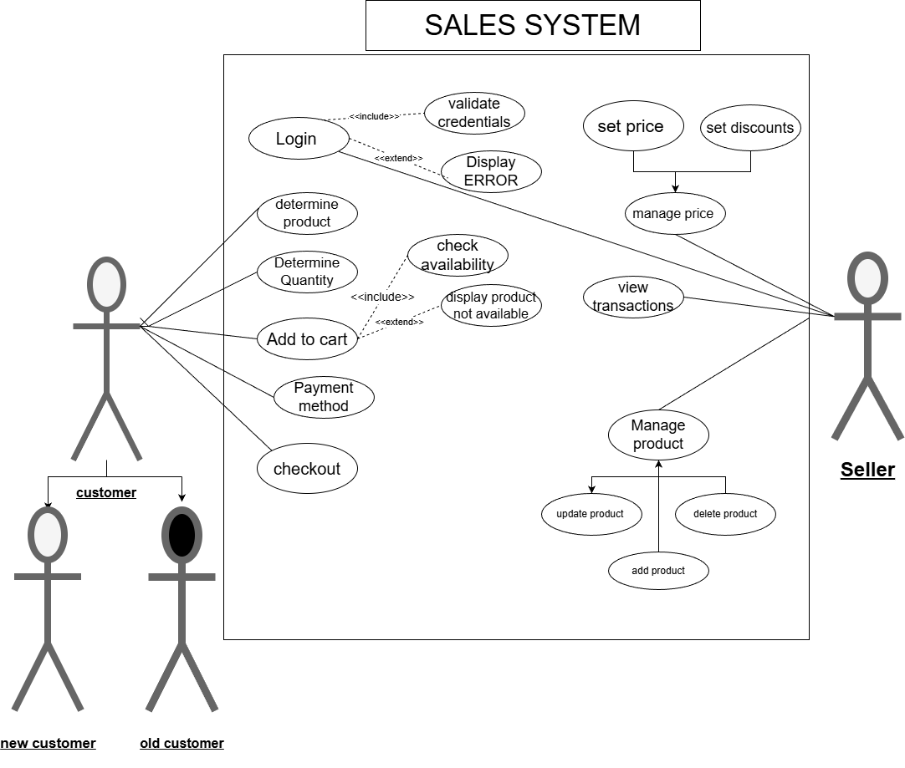
Sequence Diagram
Login Web Page
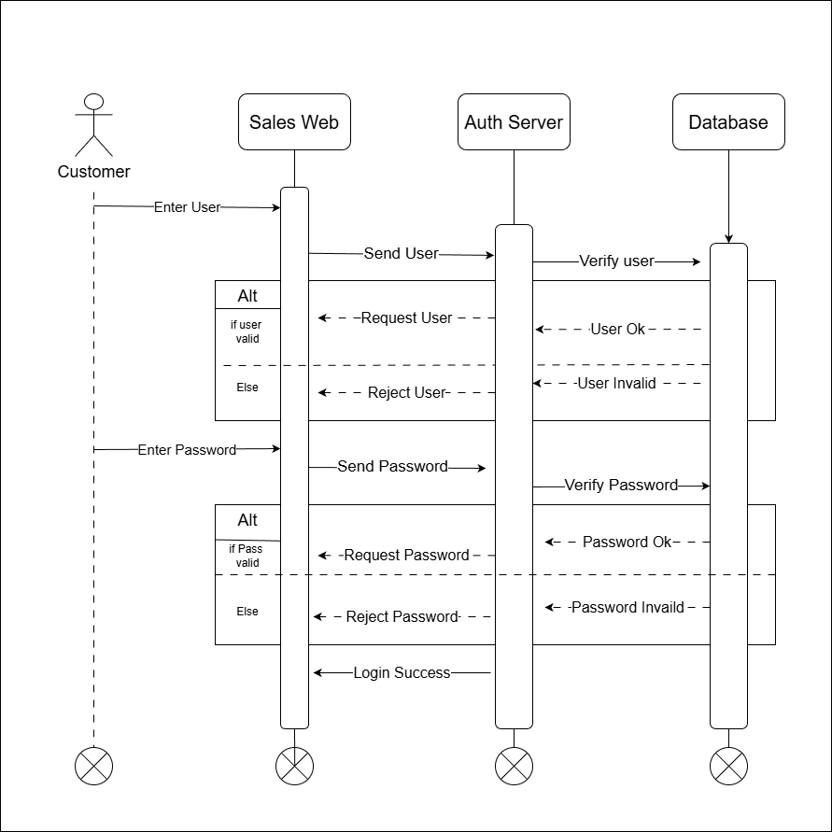
Cart
Sequence Diagram

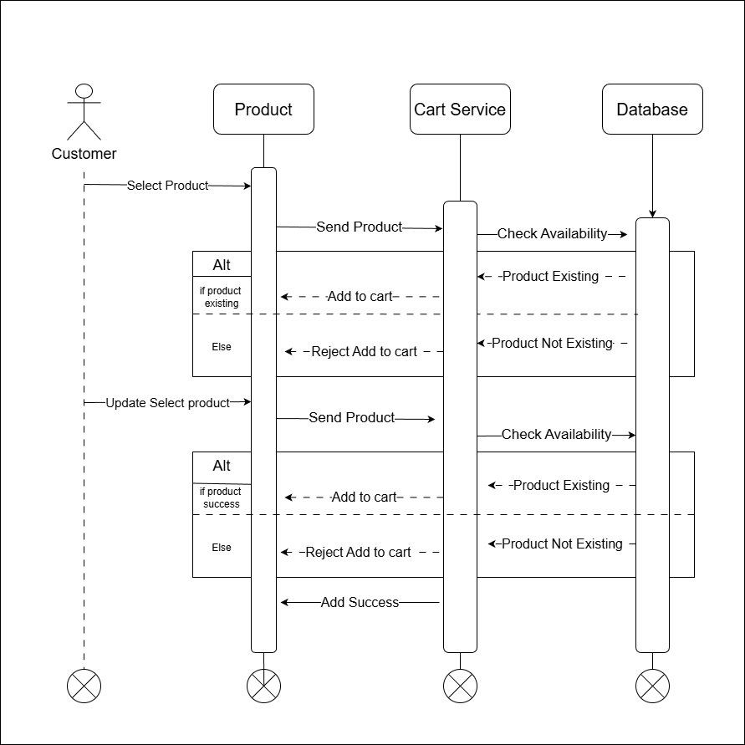
Sequence Diagram

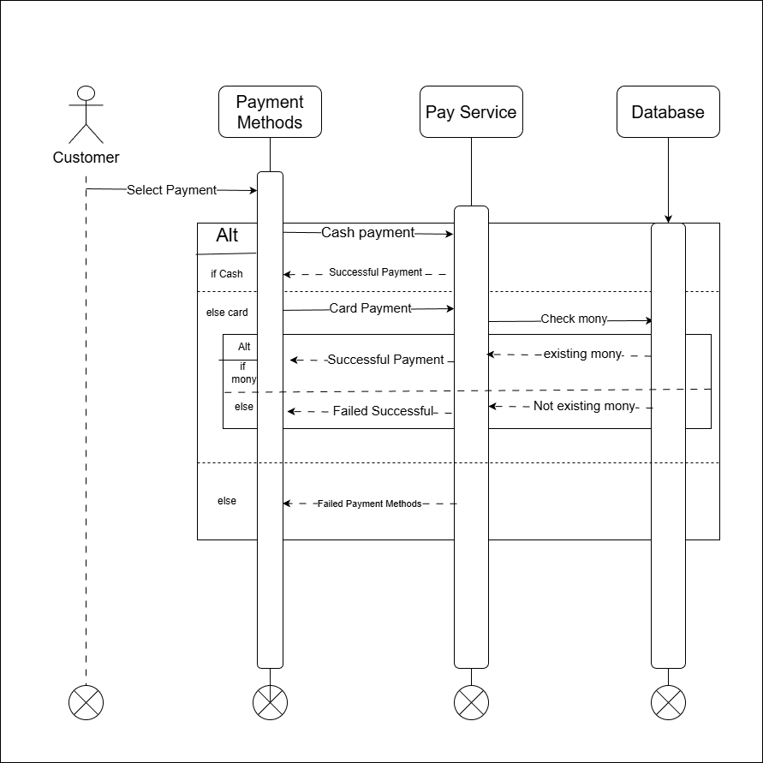
Payment Methods

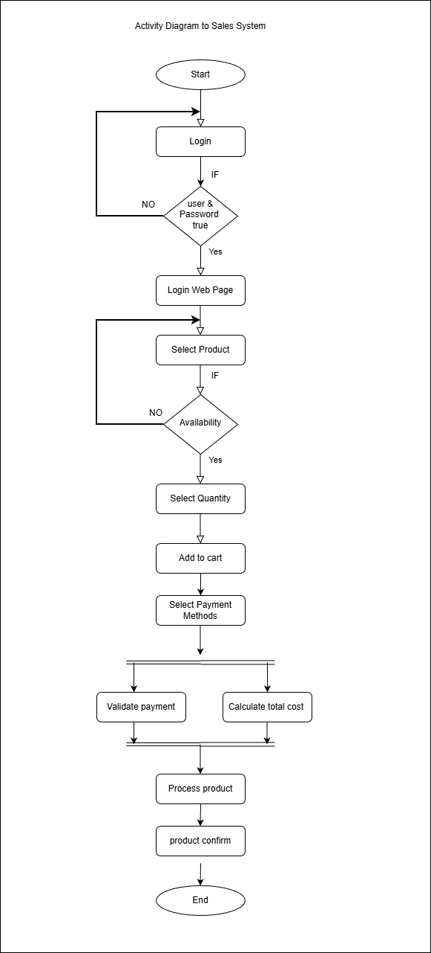

Activity Diagram

